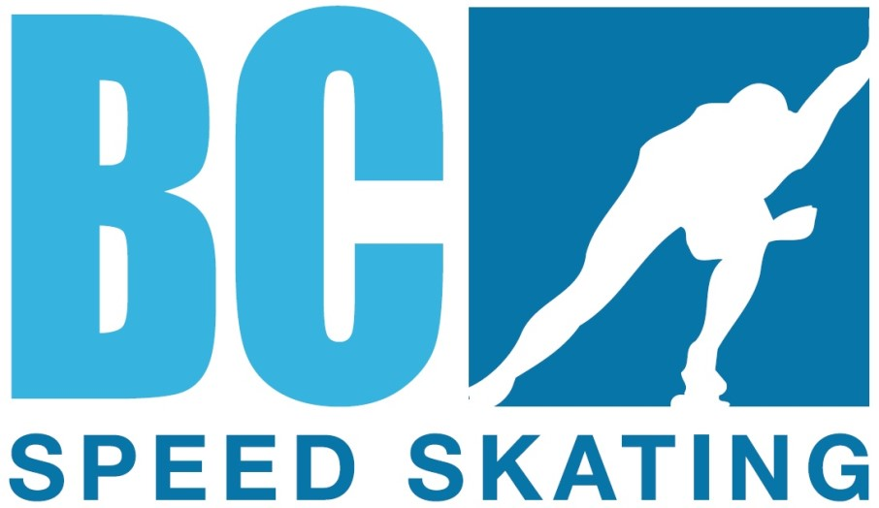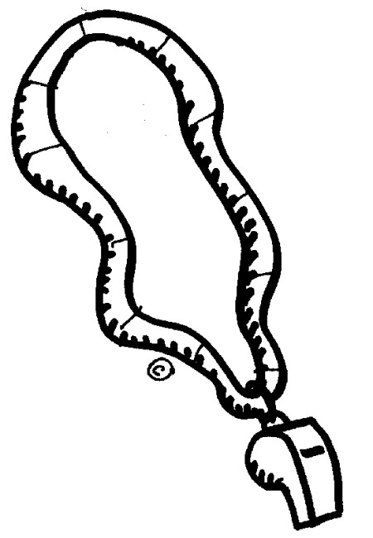

British Columbia Speed Skating Association

P. O. Box
2023
Station A, Abbotsford, BC V2T 3T8 Tel

: 604.
746.4349
Fax
: 604.746
-
4549

OFFICIALS Clinic Announcement

BCSSA ODC is pleased to announce

Type of Clinic: Level 1: Intro to Speed Skating and Officiating

Date: Friday November 24, 2017

Time: 5:30 - 8:00 pm (est.)

Clinic Cost to participant: Level 1 Clinic $ 5.00

Please pay clinic fee to: Club

Fees for the clinic will be collected at the Clinic

Course material: Manuals will be provided at the clinic

Website: http://www.speedskating.ca/officials/resources/manuals

Clinic Location: Canfor House located at the Prince George Outdoor Oval behind CN Center (4249 18thAvenue)

Sponsoring Club: Prince George Blizzards Speed Skating Club

Club Contact person: Emily Akerley. Contact: theakerley6@gmail.com

Course Conductor: Tracy Hillis, (Level 3B Referee)

This Clinic has been approved by BCSSA ODC

