The following are the instructions on how to get a skater’s time for meet entries:
- Navigate to http://www.speed-skating.bc.ca
- Click on Events and Results dropdown
- Click on BCSSA Lookup option

- When prompted for username / password:

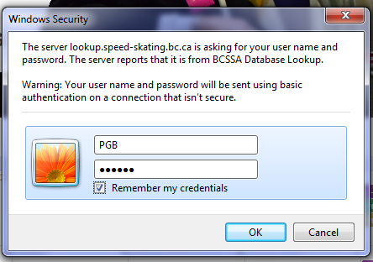

Username: PGB
Password: Ra4Ini

Note: The login is case sensitive: for password - Capital ‘R’ and Capital ‘i’ (as the forth letter in the password)

- Once the search window appears, follow the instructions to populate the search criteria:
Screenshot Below is an example. NOTE: we are ZONE 8
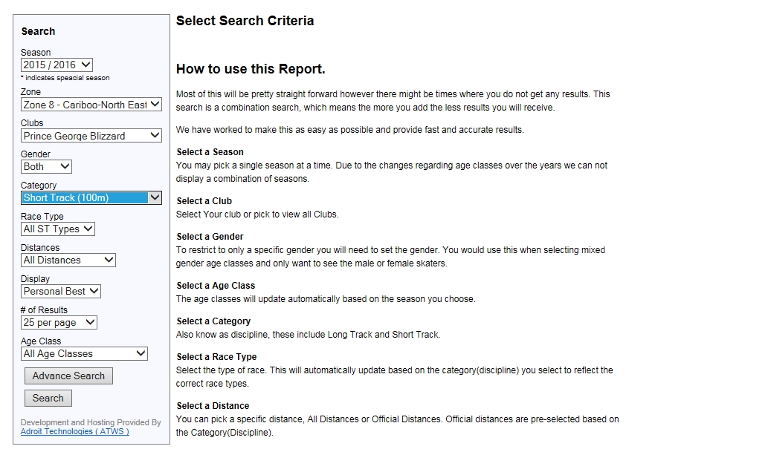

- Example of results:
