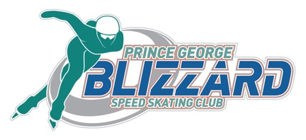

Prince George Blizzard Speed Skating Club

Central Interior Challenge/BCWG Zone 8 Qualifier

Date: Saturday, November 25, 2017

Location: Kin 1, Prince George (International size rink), Track: 111m oval/100m oval

Meet Type: Ability (all ages eligible), BCSSA Sanction

Meet Entries: List of registrants must be sent to meet recorder, Tina Peters (tandj@xplornet.ca), by 11pm Thursday, Nov. 16, 2017. Meet Entry Coordinators, please rename and use the excel spreadsheet posted on the BCSSA events calendar.

Entry Fee: Active Start: $25.00
$35 for all other age categories
Absolutely no late entries, no refunds

Registration: 7:45am Saturday, Nov. 25th at the arena. Please bring one check for each club.
We will be using helmet covers.

Schedule: Registration: 7:45 am
Warm ups begin: 8:00 am
Coaches/Officials meeting 8:30 am
Racing to follow warm up and flood 9:00 am
End of meet 5:00 pm

Lunch: Snack bags will be provided to the skaters.

Hotel: Gramma’s Inn (901 W. Central, 250-563-7174) has a good sports rate ($85 + tax), is close to Kin 1, and they have a restaurant.

For more information, please contact:

Meet Coordinator: Keri McLeod gkemcleod12@gmail.com

Meet Recorder: Tina Peters, tandj@xplornet.ca.

Central Interior Challenge/BCWG Zone 8 Qualifiers
MEET ENTRY FORM

Date: Saturday, Nov. 25, 2017 Location: Kin 1, Prince George
Time: on ice 8:00-5pm Track: 111m oval and 100m oval
Meet Type: Ability, all ages Sanctions: BCSSA Competitive Sanction
Eligibility All BCSSA/SSC registered skaters First Aid: Paramedic / Medical Doctor’s

SKATER NAME: _______________________________________CLUB: ____________________________

SSC RACING #:_________________________ M_____ F______

BIRTH DATE: _________ __________ _________ AGE on June 30, 2017: ____________________
day month year

Previous best times: (new skaters have coach submit times)
 | 100m track |  |  |  |  |  | 111m track
Category | 50m | 200m | 400m | 800m | 1200m | 1500m | 500m | 1000m | 1500m
Active Start

FUNd
L2T

T2T (all)

T2T 14, 15
Junior, Senior
A4L

WAIVER: By signing this entry form, I hereby, for myself, my heirs, executors, administrators and assigns, waive and release any and all rights and claims for damages I may have against SSC and BCSSA , the Prince George Blizzard Speed Skating Club, and all sponsors concerned, their agents, officers or members, for any and all injuries suffered by me at said contest to be held November 19, 2016 at the Kin 1 Arena, Prince George, British Columbia, Canada. This information is collected under the authority of the Freedom of Information and Protection of Privacy Act. It is required to register you in the competition. Financial information will be used to process payment. Organization of competitions/events requires that names will appear on posted race lists and result lists. Names/Images of participants may be published on boards, websites, media, newsletters and promotional material. Alternative contact and medical information will only be used in a medical emergency. If you have questions about the collection of or use of this information, contact the Competition/Event Organizer at gkemcleod12@gmail.com.

I have read and agree with the BCSSA Concussion Protocol. The BCSSA Concussion Protocol can be found at: http://www.speed-skating.bc.ca/about/safety/.

In Witness whereof, I have hereunto set my hand and seal; THIS____DAY OF ________, 2017

SKATER'S SIGNATURE: _______________________________________

PARENT'S SIGNATURE: ______________________________(if skater under 18 years of age)

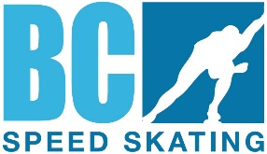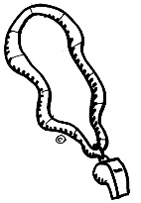

British Columbia Speed Skating Association

P. O. Box
2023
Station A, Abbotsford, BC V2T 3T8 Tel

: 604.
746.4349
Fax
: 604.746
-
4549

OFFICIALS Clinic Announcement

BCSSA ODC is pleased to announce

Type of Clinic: Level 1: Intro to Speed Skating and Officiating
Date: Friday November 24, 2017
Time: 5:30 - 8:00 pm (est.)
Clinic Cost to participant: Level 1 Clinic $ 5.00

Please pay clinic fee to: Club

Fees for the clinic will be collected at the Clinic

Course material: Manuals will be provided at the clinic

Website: http://www.speedskating.ca/officials/resources/manuals

Clinic Location: Canfor House located at the Prince George Outdoor Oval behind CN Center (4249 18thAvenue)
Sponsoring Club: Prince George Blizzards Speed Skating Club
Club Contact person: Emily Akerley. Contact: theakerley6@gmail.com
Course Conductor: Tracy Hillis, (Level 3B Referee)

This Clinic has been approved by BCSSA ODC

